 | K. J. Somaiya College of Engineering, Mumbai-77
 | (Autonomous College Affiliated to University of Mumbai)
 | IC-02 Internship Report
Student Full Name | Pranav Sanjay Kalambe | Start Date | 16-01-2021
Roll no | 1913023 | End Date | 28-01-2021
Branch | Electronics and Telecommunication | Total hours | 42 hours
 |  | completed
Year of study |  | Internship
 | Second year | supervisor | Ruchira Joshi
 |  | name
Name of |  | Internship
Organization / | &evolve (campus company) | supervisor | ruchira.j@somaiya.edu
Dept. where |  | mail id and | 99690 33511
internship/training |  | phone
completed

Please describe your internship work in space provided below

Internship Area / Project Title: Social Media Marketing.

Work done in brief: (Attach diagrams, graphs, results if required)

Six Weeks Internship:

Week 1: Learned different business features of Social media websites which includes linkedin and instagram.
Week 2: Researched about relevant hash-tag and best timings to post worked accordingly and handled instagram and linkedin account.
Week 3: Started making post and stories for instagram handle using Canva learned graphic designing.
Week 4: Made a Banner for a free workshop on ideation, made relevant post and promotional content
Week 5: Introduction to video editing software called as open shot tried to make reels and short animated videos but unfortunately failed in the end.
Week 6: Actively handled and made instagram posters regularly.

Resources / Tools used: Canva, Linkedin, Instagram.

Key learnings from the internship:

- Basic of social media marketing
- Graphic Designing
- Basic of Design Thinking
- Basic of Video Editing
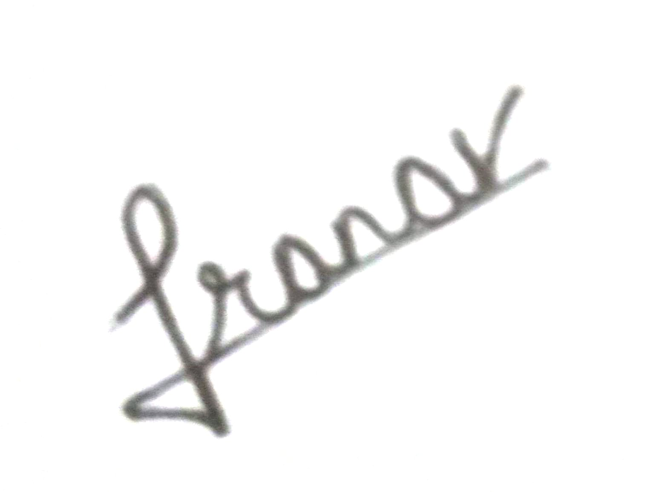
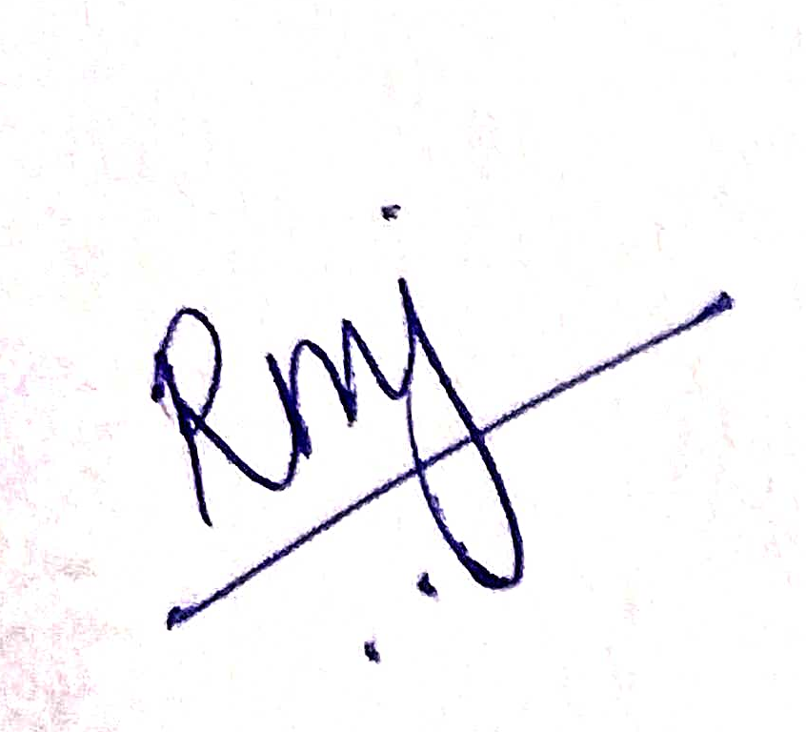

Sign of Student: Sign of Internship Supervisor
Date: 03/03/2021 Date: 03/03/2021

